*Letter of Transmittal* (i.e.,cover letter to your client, in professional letter format)(Mohit)

Bloom Energy Consultant Group

New Project Development

1299 Orleans Dr

Sunnyvale, CA 94089

November 24, 2015

Sam Liccardo

Mayor of San Jose

200 E Santa Clara St

San Jose, CA 95113

Dear Mr. Liccardo:

I am presenting a proposal that can help the City of San Jose improve its energy efficiency. Our consulting group is trying to implement solid oxide fuel cells (SOFC) that Bloom Energy makes to utilize in San Jose’s Energy System.

We need your approval to test it out in about 150 lower income home to show all the benefits of solid oxide fuel cells. SOFC are more sustainable means of energy than nuclear power. Our goals are in line with the Green Vision Goals of San Jose by creating clean tech jobs and receiving electric power from clean, and renewable sources.

In the proposal we have gone into detail of every aspect of this project. If you have any further question that we can answer, please feel free to call us at Bloom Energy or email our team of highly experienced consultants and engineers.

Your consideration of our proposal is highly valued.

Sincerely,

Bloom Energy Consultant Group

Enclosure: Proposal

*Executive Summary*

We at Bloom energy are proposing the implementation of a solid oxide fuel cells as a source of energy for lower income families in the San Jose area. It is imperative to find an alternate source of energy to reduce our reliance on fossil fuels, an unsustainable and environmentally damaging form of energy. The total cost of this endeavor is approximately 1.3 million dollars. The estimated length for the completion of this project is projected to be approximately 1 year. The project will commence within a month of obtaining the licenses and approval from the City of San Jose.

*Co-generation CHP and CCHP.....................................................................17*

*SOFC Application........................................................................................19*

*Bloom Energy SOFC.................................................................................................19*

*Bloom Energy Servers.................................................................................21*

*Bloom Energy and the Future.....................................................................22*

*Fuel Cell Challenges.................................................................................................22*

*Solar Power...............................................................................................23*

*Wind Power................................................................................................25*

*Cost .....................................................................................................................................25*

*Task Schedule.......................................................................................................................26*

*Personnel/Credentials.........................................................................................................27*

*Recommendations…………………………………………………………………………………27*

*References............................................................................................................................29*

*Table of Contents*

Introduction.......................................................................................................................... 4

Background........................................................................................................................... 5

Scope of Work ..................................................................................................................... 5

Environmental Aspects.........................................................................................................6

Technical Aspects................................................................................................................. 7

Types of Fuel ………...................................................................................................8

Why SOFC................................................................................................................10

Energy Density: How Does SOFC Compare..............................................................10

SOFC Details.............................................................................................................11

SOFC Fuel Reformer....................................................................................12

Distributed Generation...............................................................................13

Co-generation CHP and CCHP.....................................................................13

SOFC Application........................................................................................14

Bloom Energy SOFC.................................................................................................15

Bloom Energy Servers.................................................................................16

Bloom Energy and the Future.....................................................................17

Fuel Cell Challenges.................................................................................................17

Solar and Wind Power.............................................................................................17

Solar Power................................................................................................18

Wind Power................................................................................................18

Cost ......................................................................................................................................19

Task Schedule.......................................................................................................................

Personnel/Credentials .........................................................................................................

Budget..................................................................................................................................

Conclusion……………………………………………………………………………………………………………………….

References............................................................................................................................

*Introduction*

We are a part of the consulting division at Bloom Energy, we work with many different companies to implement Solid Oxide Fuels in their workspace. Our goal is to provide research and development plans in transitioning or integrating alternative energy like Solid Oxide Fuel Cells on existing energy sources. We evaluate ground breaking technologies that can substantially make a difference in our changing environment and implement these technologies implement Solid Oxide Fuel Cells for residential purposes to produce more energy.

A fuel cell is a device that generates electricity by a chemical reaction (Smithsonian Institution, 2008). Every fuel cell has a negative and positive electrodes, the negative is the anode and the positive is the cathode. The electricity that is made is by the reaction is produced at the electrodes. Fuel cells require two main ingredients Hydrogen and Oxygen which can be easily obtained in different places.The main reason to use fuel cells is that they generate electricity with very little pollution–much of the oxygen and hydrogen used in generating electricity ultimately combine to form a harmless byproduct, namely water (Smithsonian Institution, 2008).

The City of San Joses uses electricity from power plants, where electricity is made by massive generators. These power plants use coal, which is harmful for the environment and is not very effective in transferring all its resource into electrical energy. We propose that the city of San Jose integrate alternative energy sources using SOFC (Solid Oxide Fuel Cells) blocks to the residential sector as a pilot run. Using SOFC as a source of energy can provide more energy, with less harm to the environment. Bloom Energy, the company we work for is a large manufacturer of SOFC blocks. Bloom Energy generates clean energy with the use of fuel cells with is also a reliable source of power. There is very little environmental impact, making the Bloom Energy products one of the most sustainable solutions. There is measurable success in integrating these blocks to each household. The key to the success of our proposal is to make the SOFC blocks the primary source of energy in the city of San Jose and make the grid the secondary source.

We plan to integrate Solid Oxide Fuel Cells into 150 homes in the City of San Jose to see show you that Solid Oxide Fuel Cells can greatly benefit the residents of San Jose and will be better for the environment. Our goals line up with San Jose’s Green Vision goals too, using cleaner energy and reduce the amount of pollutants in the environment. Fuel cells provide high efficiency and this will reduce the cost to produce electricity which can help residents save money. Solid Oxide Fuel Cells are a reliable source of energy and many business are even using fuel cells to go of the grid. Fuel cells are very quiet and can easily be scaled to output a large amount of power. Fuel cells do not take up a lot of space and are being designed so they can be portable as well. They require little to none maintenance as long as fuel is provided and last very long. In our proposal we will discuss why fuels are a great source of energy, how fuels are better for the environment, how fuel cells work, alternatives forms of energy, the budget required to implement fuels and how Bloom Energy can help the City of San Jose improve its energy infrastructure with the use of fuel cells.

*Background*

The rising energy cost and the dependency from fossil fuel has encouraged the public in search for potential alternative energy. It’s important that we move from this dependency because of environmental concerns and the need to become more sustainable. Today, the indication of climate change is becoming more severe. Some alternative energies currently used now are solar, wind, biomass, and hydroelectric. These energies are tied to the electric grid. In the past few years private companies and the government have invested in alternatives to reduce hazardous waste, and to minimize the climate change affect. An important sector we should include in this movement is the residential sector.

The residential sector must seek the benefits of today’s alternative energy conversion. It’s important that every household become independent from fossil fuel because improving technology of producing energy has become more efficient and affordable. Solar energy and wind power are two popular alternatives. The cost of these alternative energies is shown in Fig. 1 from ___. (). Another alternative that should be considered is fuel cell technology, in particular, SOFC.

For example, solar panels have become much cheaper and are more efficient from its inception. Solar panels are one of the most popular household installations right now because of government rebates coupled with low cost cells. In addition, the cost of utilities is dramatically reduced. Solar power has advantages and disadvantages.

*Scope of Work*

The use of solid oxide fuels cells present innumerable opportunities to increase efficiency, reduce emissions, and reduce costs. We will manufacture a solid oxide fuel cell, specifically an ES-5700 fuel cell, for the residential sector. The fuel cell should have ample energy to supply power to meet the baseload needs of 160 homes. To ensure our product meets the needs of our customers, we will limit our trial run to one fuel cell for 150 homes. We plan on installing our fuel cell in South San Jose due to its large concentration of residences. We would like to target lower income residences to provide a financial break for families in that area.

Several steps are required to reach our goal of installing a fuel cell in San Jose to provide cheaper electricity for lower income families. First we must meet with the City of San Jose to receive approval for our endeavor. Given that San Jose would like to get their electricity from clean sources as well as creating clean tech jobs according to their Green Vision, our plans would directly correlate with this desire (San Jose, 2007). Once we are given consent from the city we must establish the optimal location for our fuel cell. We will look for an area within San Jose where the majority of residents are considered low income families or individuals. With this prerequisite in mind, we will also need the area to have an optimal location to place our fuel cell. An opportune location would be a vacant building that could be repurposed to house our fuel cell to be maintained and monitored there. Once the area of homes to utilize the fuel cell, as well as the location of the housing of the fuel cell, is determined we can advance in our process of integrating the fuel cell.

After we have found a location that meets our desires, we will begin the process of requesting and obtaining permits. The permits that we would need relate to housing the fuel cell in its own location as well as changing how the electricity goes to each house. To provide electricity to the houses in our desired location, we would have the fuel cell’s power travel through the existing power lines to prevent the need to construct our own grid, both a costly and timely endeavor.

The last aspect is installation. The installation process will be a smooth procedure for both the city and the recipients of our project. Once the SOFC has been properly installed in its private building, the last step will be to make the transition from the electricity from the service provider to our SOFC. The power will be cut to the region where we will be conducting our project, we will then activate the SOFC, and then the residences will be operating solely on the power from our fuel cell.

The fuel cell will require constant maintenance over its lifetime. A team will be assigned to conduct regular maintenance as well as performing any upgrades that prove beneficial. The fuel cell has a long life ahead of it and it is our goal to keep it performing to the standards we have promised.

*Environmental Aspects*

Solid oxide fuel cell integration within a home can have many benefits with minimal consequences. A viable replacement to current energy sources must be more efficient, produce less harming emissions, and have a measure of safety that will be no harm. Solid oxide fuels cells fill these categories hence can be a viable replacement to current energy sources. The production of electricity is a process that uses fossil fuels in turn release emissions that damage our ozone and lead to problems such as global warming. By replacing the current methods of energy production with solid oxide fuel cells many differences can be made.

A solid oxide fuel cell is very efficient itself as it intakes a form of fuel such as hydrogen or any biogas plus oxygen rich air to output water and carbon dioxide. However the carbon levels are very little compared to fossil fuels which will benefit the public. The efficiency of one fuel cell is hard to analyze but a full structure of solid oxide fuel cells are very efficient proved by the current products at Bloom Energy.

The solid oxide fuel cells product will attain a power generation between 100kW to 300kW. This is heavily dependent on the size and power usage each of residential building. The sample size will be a variety of residential houses that will improve data analysis for this alpha test. The efficiency is important as this differentiates solid oxide fuel cells. The current architecture of Bloom Energy products can operate for 96 hours during power outages, provide a relative a max load of 50kW and can be connected in a max parallel of 5 units (Bloom Energy, 2015). The smaller versions will have varying number for each standard but the efficiency will remain intact.

The byproduct of using fuel cells is mainly water and relative amounts of gasses. Since the solid oxide fuel cell modules run high temperatures the byproducts can be used to power other appliances such as heaters and air conditioners (Betts, 2015). By using byproducts to power other appliances that reply on natural gases furfure reduces the overall output emissions of a single residential home. The safety and environment damage is little to none when it comes to solid oxide fuel cells. The by product will be released into atmosphere but plans to implement air conditioners working off the byproduct will be implemented in the future. Solid oxide fuel cells installed will run at very high temps which can be a problem if the cooling system fails but to prevent any accidents the module will shut down before to preserve safety of the users.

*Technical Aspects*

A solid oxide fuel cell behaves very much like a battery. A solid oxide fuel cell converts fuel like hydrogen and other gases to produce electricity without having a combustion reaction. These fuel cells are very efficient in converting almost all fuel to electricity and are much more efficient than the average coal power plants and other combustion reactions (Singhal, 2014). The reaction takes place at the anode. Oxygen reacts with H2 or sources of fuels, and the free electrons produce electricity by moving to cathode to complete the circuit. Solid oxide fuel cells are efficient because reaction tries to use all the fuel to convert into energy. The by products of this reaction are water (H20) and CO2.

Besides being efficient solid oxide fuel cells also generate little to none harm to environment because the amount of CO2 that is outputted is very small. Solid oxide fuel cells have other advantages, like the face that is use different types of fuel to generate electricity that range from hydrogen to hydrocarbons and other types of gases. Fuel cells can generate a steady amount of electricity as long as oxygen and fuel are constantly supplied, which makes them very reliable to supply power to houses. Fuel cell technology is rapidly growing and this technology can be used as a power supply for all sorts of applications including powering homes in large cities like San Jose.

Fuel cells operate at very high temperatures and fuel in the cells can be mixed with different types of fuels since the temperature is very high. Solid oxide fuel cells can be used to produce small amounts of electricity to large amounts power because of their fuel flexibility. Different types of material can be used to make fuel cell, improving their stability as well as making them available for different applications. Solid oxide fuel cells are now stable and excel in the long performance (Singhal, 2014). This proves that solid oxide fuel cells can compete with other sources of energy, since they will last long and are very efficient in converting fuel to electricity.

Now that fuel cells can be produced to last, with reliable materials, solid oxide fuel cells can be used for commercial use. Bloom Energy is leader in the solid oxide fuel cell industry and has sold over several hundred 100kW fuels cells for customers for commercial use. A lot of research is being conducted all around the world to reduce the cost of solid oxide fuel cells to make them readily available for customers.

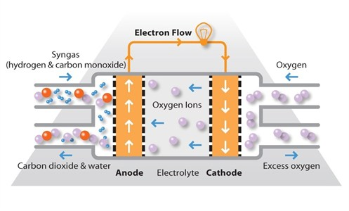

Figure 1 :This figure shows how a solid oxide fuel cells works and the necessary parts needed to make it work. (Matthey, 2015)

**Types of Fuel Cells**

There are numerous types o Fuel Cell. (Fuel Cells 2000, 2105). These are the following:

* 1. AFC – Alkaline fuel cell
  2. PEM – Proton exchange membrane fuel cell
  3. DMFC – Direct methanol fuel cell
  4. MCFC – Molten carbonate fuel cell
  5. PAFC – phosphoric acid fuel cell
  6. SOFC – Solid oxide fuel cell

The characteristic of each type of the fuel cell technology posses its own unique chemistry, operating temperatures, catalysts, and electrolytes. Application is defined by the fuel cells’ operating temperature. Fig _ shows the operating temperature of each type of fuel cell.

Example: Lower temperature fuel cells such as PEM and DMFC are used for passenger vehicles, while MCFC and PAFC fuel cells are used for stationary power generation.

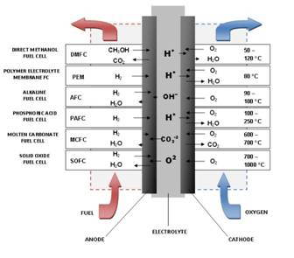

Fig 2 Types of Fuel Cells (“Types of Fuel Cells,” 2015)

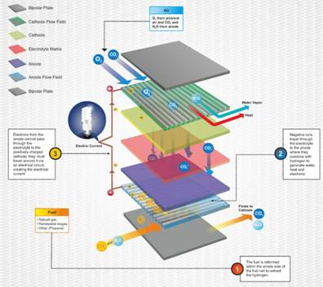

Fig 3 Planar SOFC stack (Bloom Energy, 2015).

**Why SOFC?**

There are significant reasons why SOFCs are the fuel cell technology of choice. These points will be discussed in detail of this report.

*First*, relative to other fuel cell types, SOFCs are fuel-flexible – they can reform fuel. With internal reforming, this reaction is heat-absorbing and will tend to cool the cell and the module. This advantage can reduce the need for cooling air consequently reducing the parasitic power needed to supply that air. (Choudhury, et al, 2013).

*Second*, experimental data and analyses suggest that advanced SOFCs have an economic entitlement relative to prior established commercial technologies and the National Energy Technology Laboratory evaluated fuel cell types. Planar SOFCs using a thin ceramic electrolyte could operate at lower temperatures (<800°C). Furthermore, the short conduction path from the anode of one cell to the cathode of the next results in lower ohmic losses and, therefore, higher stack efficiency and lower cost than many of its predecessors. (Choudhury, et al, 2013).

*Third*, SOFC is a high-temperature technology, thus its exhaust streams will tend to have high temperatures. High grade exhaust heat can enable high-efficiency combined cycle combinations such as SOFC/gas turbine/steam turbine. (Choudhury, et al, 2013).

Using Cogeneration with SOFC, which will be discussed later, makes SOFC will increase the efficiency a lot more. Because conventional power plants are only 35% efficient, up to 65% is lost energy. In the application part of this analysis, SOFC can provide up to 83% of efficiency.

*Lastly*, SOFCs are ideal for carbon capture in that the fuel and oxidant (air) streams can be kept separate by design, thereby facilitating high levels of carbon capture without substantial additional cost. (Choudhury, et al, 2013).

**Energy Density: How Does SOFC Compare**

SOFCs as a Clean and Efficient Path to a CO2-Neutral Economy Powered by H2 , Biofuel, or Solar-fuels. SOFCs have many characteristics which make them attractive for producing electricity. SOFCs have the highest theoretical and demonstrated efficiencies of any chemical to energy conversion technology: 50-60% 1-6 when electricity alone is valued, and 70-9 4-6 when both electricity and high quality waste heat are valued.

SOFCs also have some of the highest gravimetric and volumetric power densities of any electricity generation technology. Unlike competing energy conversion technologies such as gas turbines, SOFC efficiencies are size independent; making them effective for applications ranging from 1 Watt to multi-Megawatts. (Promise, 2013). Fig _ illustrates that SOFCs specific power is comparable with gas turbine in the MW scale.

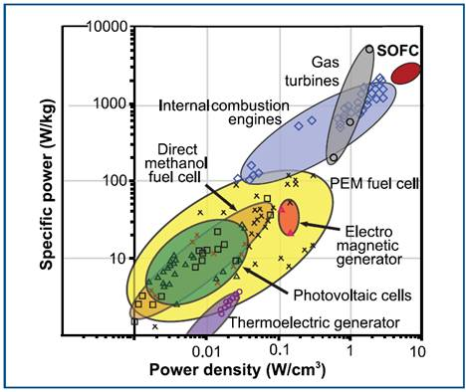

Fig 4 illustrates the Gravimetric and volumetric power densities for various electricity generation technologies. (Promise, 2013).

**SOFC Details**

There are two configuration of SOFC – tubular and planar. Tubular SOFCs has been

confirmed by successful operation in several power generation systems of up to 250 kW size, though their cost still remains to be reduced. Planar SOFCs, particularly anode-supported, provide much higher power densities and potentially much lower cost than the

tubular cells.

Planar SOFC is a type of fuel cell that holds the greatest potential of any fuel cell technology. (Bloom Energy, 2015). An article from Renewable and Sustainable Energy Reviews supports Bloom Energy’s claim of not only the highest potential, but also the highest in efficiency. Fig _ shows different type of fuel cells operated at elevated temperature. The highest efficiency was achieved up to 63% with planar SOFC systems, and has also achieved .5amps/cm2 at > 0.75V. (Blum,L. et al, 2011).

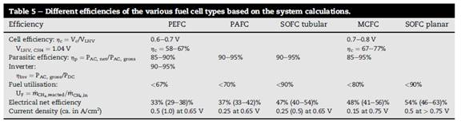

Fig 5 Efficiency comparison of different type of fuel cells operating at elevated temperature.(Blum, L. Et al, 2011).

*SOFC Fuel Reformer*

The basic component of a SOFC power plant consist of a fuel processor, desulphurizer, fuel cell power module, power conditioning equipment for DC-AC converter, and process gas heat exchanger. Steam reforming reaction is used to reform hydrocarbon fuels, such as natural gas. (Choudhury, 2013). This reforming process can be internal or external. Due SOFC high temperature process it can reform fuel efficiently. External reforming requires methane (natural gas) is converted to hydrogen and CO outside the fuel cell. Endothermic steam reforming reaction are operated separately and there is no direct heat transfer. In internal reforming, endothermic reaction from the steam reforming reaction and exothermic reaction from the oxidation reaction operate together in single unit. (Choudhury, 2013). Fig _ shows the reforming process of how fuel is managed prior to chemical reaction of SOFC system.

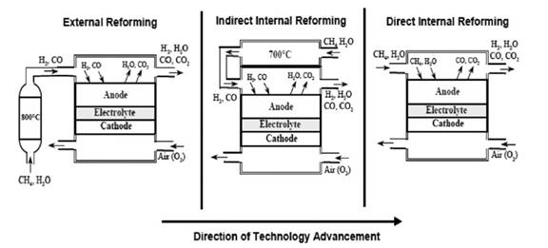

Fig 6 Fuel Cell Configuration. (Choudhury, 2013).

*Distributed Generation*

As highlighted in the SOFC benefits, Distributed Generation is a concept of point of consumption where generating power on-site, rather than centrally, eliminates the cost, complexity, interdependencies, and inefficiencies associated with transmission and distribution. Like distributed computing (i.e. the PC) and distributed telephony (i.e. the mobile phone), distributed generation shifts control to the consumer. In addition power losses from transmission lines due to power line resistance are lost by up to 6%. (Elmer T., 2015).

*Co-generation CHP and CCHP*

Because of Fuel Cells’ ability to produce electricity, heat, and water from electrochemical process, it has become an attractive option for stationary building applications to use combined heat power (CHP) and combined cooling heat and power (CCHP) or tri-generation systems. (Elmer T., 2015).

In the case of CHP, the heat produced in the electrical generation process is recovered and the heat is used for space heating or for domestic hot water. The system efficiency can elevate from 20% to 90% depending on utilization. The key to maximum efficiency is accurate load sizing of the system. The use of high temperature SOFC system currently shows the greatest electrical efficiency and high temperature heat output. CHP is a feasible technological option for domestic application, but cost, reliability, durability, and fuel supply are issues that need to be addressed to effectively integrate for domestic built environment. (Elmer T., 2015). Fig _ illustrates the residential application.

For the tri-generation systems built for small domestic applications, feasibility is strong and shows great promise. The Fuel Cell tri-generation can create substantial energy savings, shows reduction of pollution, and lower operational cost. In comparison to a power plant, a 1.5KW low temperature SOFC liquid desiccant tri-generation system can reduce CO2 emission by up to 70%. (Elmer T., 2015).

The major challenge of both CHP and CCHP is the capital cost. Significant reduction can be made through government support or technological innovation to make this affordable in the future. (Elmer T., 2015).

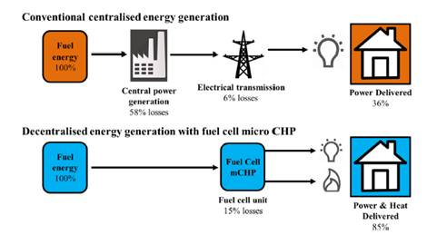

Fig 7 Scheme of the advantages of decentralized energy generation with fuel cell micro CHP compared to conventional centralized energy generation. (Elmer T., 2015)

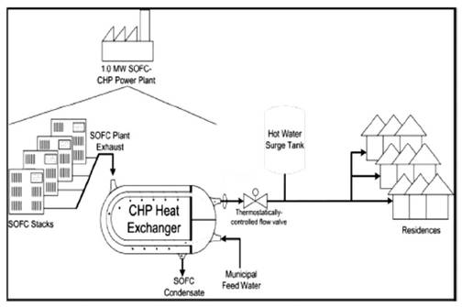

Fig 8 SOFC-CHP system for residential application. (Choudhury, 2013).

*SOFC Application*

There are three main application of SOFC. These are combined cycle power plant, cogeneration/trigeneration, and residential application. Areas of great interest in SOFC application are residential (1-10kW), power generation (several MW), and commercialization end (25-250MW). Because it generates significant amount of heat, it impacts system efficiency, economics, and environmental issues. (Choudhury, et al, 2013).

**Bloom Energy SOFC**

Bloom Energy uses (planar) SOFC squares because other fuel cell types require expensive precious metals, corrosive acids, or hard to contain molten materials. (Bloom Energy, 2015). Bloom Energy’s patented technology enables them to manufacture low cost ceramic based SOFC squares (planar SOFC), high electrical efficiency, and fuel flexibility.

SOFC from Bloom Energy makes the case of the right alternative energy because of the following benefits:

1. SOFC are the most efficient (fuel input to electricity output) fuel cell electricity generators currently being developed world-wide. Demonstrated efficiency – 47%, Achievable – 55%, Hybrid – 65%, with CHP – 80%. (Stambouli, A. B., & Traversa, E. 2002).
2. Reliability – provides continuous electricity and heat. Fuel cells are self-sustaining energy source. In comparison to other energy capture devices like solar cells, fuel cells have tremendous advantage of having the highest real time energy efficiency of 70%. (Prashantk, K., 2013).
3. Fuel flexibility – fuel cell technology can be operated with different types of fuels. (Williams, M.C. et al, 2006).

1) Low or high purity H2

2) Liquefied natural gas

3) Pipeline natural gas

4) Diesel

5) Coal synthesis gas

6) Fuel oil

7) Gasoline

8) Biogases

1. Distributed generation – point of use which allows the user to have electrical power the grid as backup power. In addition, this also eliminates transmission and distribution anytime. This eliminates dependency from the grid. (Bloom Energy, 2015).
2. Reduced greenhouse gas emission – depending on the type of fuel it uses, the CO2 emission can be reduced to as no emission. Fuels such as natural gas or biogas CO2 is still far less than an internal combustion engine. (Prashantk, K., 2013).
3. High temperature systems such as SOFC can be coupled with other applications such as Combined Heat and Power (CHP) which can increase the efficiency of the system dramatically. (Elmer T., 2015).
4. Small physical footprint stacked fuel cells makes the Bloom Energy alternative energy more attractive that other alternatives in comparison with other alternative energy sources require larger footprint. (Bloom Energy, 2015).
5. Small to no water usage. (Bloom Energy, 2015).

*Bloom Energy Servers*

Bloom Energy uses SOFC made of low cost (planar) solid ceramic square materials that are capable of producing up to 25 watts of power. These squares are then sandwiched to form a fuel cell “stack”. These stacks are packaged to size of a “loaf of bread” which are

interconnected creating enough energy to power an average home.

Bloom Energy server is one of the most sustainable solutions on the market today. Compared to fossil fuel sources, Bloom Energy Server provides 200kW of power, enough to meet the baseload needs of 160 average homes or an office building... day and night, in roughly the footprint of a standard parking space. For more power simply add more energy servers.(Bloom Energy, 2015).

One of the motivations with the Bloom Energy servers is the emergence of Distributed Generation. Electricity from the grid suffers from up to 6% from transmission line losses. For servers that are installed at the point of use, these losses are not wasted. In addition, this creates independency from the electrical grid. (Elmer T., 2015).

Another benefit from Bloom Energy servers is the reliability of clean energy 24 hours per day, 365 days per year with no intermittent disturbance. (Bloom Energy, 2015).

**NOTE:**

There is no information of how Bloom Energy manages its fuel and reforming system in its site. These information maybe proprietary and patents may need to be accessed.

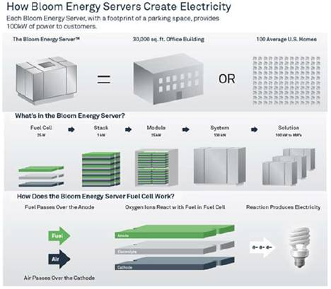

Fig 9 Bloom Energy Server configurations (Bloom Energy, 2015).

*Bloom Energy and the Future*

Although Bloom Energy offers only the Bloom Servers to provide efficient and low cost electricity, coupling CHP or CCHP as it becomes cheaper and proven as an environmental solution.

**Fuel Cell Challenges**

There are still obstacles that need to be addressed to validate Fuel Cell technology. Key challenges for Fuel Cell commercialization as well as hydrogen infrastructure technologies are described as next step in research, design, and development. (Challenges, 2015).

1. Fuel Cell Cost and Durability
2. Hydrogen Storage
3. Hydrogen Production and Delivery
4. Public Acceptance

**Solar and Wind Power**

*Solar Power*

Photovoltaic (PV) effect is the basis of the conversion of light to electricity in photovoltaic, or solar, cells. A built-in-potential barrier in the cell acts on negatively charged electrons to produce a voltage (the so-called photovoltage), which can be used to drive a current through a circuit. Single-crystal silicon form these cells and are tied together to form an array. This array, with respect to the built-in potential the solar cells generate, will have stronger current density to produce electricity for most applications.

(Solar Arrays, 1982). In Fig_. PV system efficiency has been improving over the last 25 years. The typical Crystalline Silicon efficiency has increased to over 16% (as an example). In addition, the cost with respect to the solar panels purchased today has been improving as shown on Fig _. This electrical energy is then stored in banks of batteries. Energy stored from batteries convert DC power to AC by inverters where this now used by the consumers.

Some of the advantages of having solar are as follows: They are renewable, abundant, sustainable, environmentally friendly, good availability, reduces electricity cost, low maintenance, governmental incentivized, and low maintenance. (Solar Pros and Cons, 2015).

Some of its disadvantages are: they are initially expensive, intermittent, energy storage is expensive, associated with pollution, exotic type of materials used, and footprint. (Solar Pros and Cons, 1982).

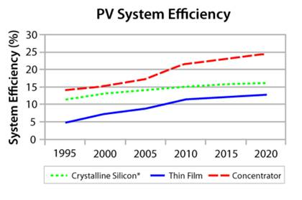

Fig 10 Chronological PV system efficiency (System efficiency vs. time for different technologies, 2015)

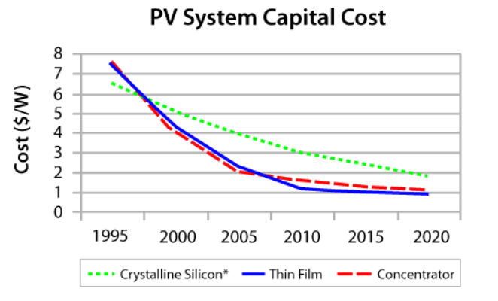

Fig 11 Chronological PV Capital Cost (PV System Capital Cost vs time, 2015)

*Wind Power*

One of the biggest advantages wind power has over traditional energy technologies is the way in which it generates power. Wind turbines operate on a simple principle. The energy in the wind turns two or three propeller-like blades around a rotor. The rotor is connected to the main shaft, which spins a generator to create electricity. Click on the image to see an animation of wind at work. (How wind turbines work, 2010).

Wind technology offers several benefits. It’s a clean fuel source and sustainable. It is cost effective and it creates jobs.

Some of the challenges of wind power are as follow: Wind power must still compete with conventional generation sources on a cost basis (due to higher initial investment); Good wind sites are often located in remote locations with respect to where electricity is needed; Wind resource development may not be the most profitable use of the land; Turbines may cause noise and aesthetic pollution; The turbine blades may damage local wildlife.

**Cost**

In an article from WIRED Business in 2010, Bloom Energy cost was compared to Solar and Wind energy. CEO and Founder K.R. Sridhar said the a Bloom server will produce power for nine to 10 cents per kilowatt hour after incentives. This price includes service, maintenance, gas and all other costs associated with running it. (Bloom Vs. Solar: Which One is Best?, 2010).

Another comparison released by Forbes Business in 2015 as shown on Fig _ shows that wind operates at 11.3 cents per kilowatt hour and solar operates at 13 cents per kilowatt hour. This is based on LCOE(Levelized Cost of Energy) which is a way to combine all the construction, fuel and operational costs into a form that can be compared among all energy sources. The LCOE also has assumptions about financing periods, taxation, depreciation and owner costs that are hard to compare between short-lived systems like wind and long-lived systems like large hydro and nuclear. Based on alternatives shown in this LCOE chart, Wind is much cheaper than solar.

With the assumption of Bloom Energy server’s ability to cut cost to 10 cents per kilowatt hour, it appears that Bloom Energy server is able to compete. The total cost of the project should run around 1.3 million dollars, which should include the the SOFC and setup of all the equipment and supplies. A part of the money will also go to run the project, which might include facilities and administrative costs.

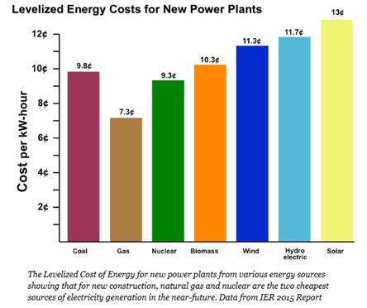

*Task Schedule*

This Gantt chart relates to your actual product or service. It could span months or years, depending on the project. Give a description and a timeline from implementation to completion of the project. Begin with the starting date of your project, include the milestone (progress) dates, and be sure to include the completion date of the whole project. Present your timeline either as a Gantt chart or a milestone chart (see examples in Markel by using the index or<http://www.ganttchart.com/Examples.html>). You can easily develop a Gantt chart using Excel or Word. Alternatively, simple, free online-software is available.

Talk with city of SJ (1 month)

Research and development (2 months)

Manufacturing (1 month)

Permits (2 months)

Planning (1 month)

Contracting (2 weeks)

Installation (6 months)

Maintenance (lifetime)

*Personnel/Credentials*

The proposal is being implemented by the consulting division at Bloom Energy. The consulting team consist of four members: Anahit Sarao, Mohit Bhasin, Noel Manto, and Maxwell Cheshier. The group is highly qualified in the area of engineering and has an extensive level in environmental engineering. The main purpose of this team is to take an engineering viewpoint of the energy crisis and attempt to find a viable solution. Environmental aspect is involved within every engineering project, this is mainly directed toward the betterment of the global environment.

*Budget (Later) SOMEONE NEEDS TO FINISH THIS*

Provide a written description as well as a table. For many proposals, a cost/benefit analysis will be appropriate in the description. Give a cost breakdown and the total cost for implementing the proposal. You should consider direct costs such as salaries, fringe benefits, materials, equipment, travel, and publication costs. Also consider indirect costs required to run the project, which might include facilities (rental office space, lighting, or heating) and administrative costs (phones, insurance). The numbers can be estimates.

**Conclusions**

There are several factors to determine on which alternative is better: solar, wind, or Bloom Energy SOFC. To make distinctions, we should take in consideration some of the following points: the amount of CO2 emission, the demand for electricity, footprint, the requirement to run the system, government incentives and the cost of the setup.

*References*

Cunningham, W, & Cunningham, M (2006). *Principles of environmental science: Inquiry and applications*. New York: Mcgraw Hill.

Johnson Matthew. (Photograph). (2015).Fuel Cell Today. Solid Oxide Fuel Cell.

http://www.fuelcelltoday.com/technologies/sofc

Singhal, S. C. (2014). Solid oxide fuel cells for power generation. *WIREs Energy and Environment, 3*(2), 179-94. doi:10.1002/wene.96

Wen, H., Ordonez, J. C., & Vargas, J. V. C. (2013). Composite electrode modelling and optimization for solid oxide fuel cells. *International Journal of Energy Research, 37*(2), 95-104. doi:10.1002/er.2941

Smithsonian Institution. (2008). Fuel Cell Basics. Retrived from : <http://americanhistory.si.edu/fuelcells/basics.htm>

Triphob, N., Wongsakulphasatch, S., Kiatkittipong, W., Charinpanitkul, T., Praserthdam, P., & Assabumrungrat, S. (2012). Integrated methane decomposition and solid oxide fuel cell for efficient electrical power generation and carbon capture. *Chemical Engineering Research & Design, 90*(12), 2223-2234. doi:10.1016/j.cherd.2012.05.014

Yang, W., Zhao, Y., Liso, V., & Brandon, N. (2014). Optimal design and operation of a syngas-fuelled SOFC micro-CHP system for residential applications in different climate zones in china. *Energy and Buildings, 80*, 613-622. doi:10.1016/j.enbuild.2014.05.015

Herron, S., & Williams, E. (2013). Modeling Cascading Diffusion of New Energy Technologies: Case Study of Residential Solid Oxide Fuel Cells in the U.S. and Internationally. Environmental Science & Technology, 47(15), 8097-8104. doi:10.1021/es400063a

Ellamla, H. R., Staffell, I., Bujlo, P., Pollet, B. G., & Pasupathi, S. (2015). Current status of fuel cell based combined heat and power systems for residential sector. Journal Of Power Sources, 293312-328. doi:10.1016/j.jpowsour.2015.05.050

Betts, D. A., & Graham, M. (2015). Development of a Fuel Cell Integrated Combined Power and Air Conditioning System. *ASHRAE Transactions*, *121*(2), 1-8.

Kerman, K., & Ramanathan, S. (2014). Performance of solid oxide fuel cells approaching the two-dimensional limit. *Journal Of Applied Physics*, *115*(17), 174307-1-174307-7. doi:10.1063/1.4874738

Blum, L., Deja, R., Peters, R., & Stolten, D. (2011). Comparison of efficiencies of low, mean and high temperature fuel cell Systems. *International Journal Of Hydrogen Energy*, 36(17), 11056-11067. doi:10.1016/j.ijhydene.2011.05.122

Elmer, T., Worall, M., Wu, S., & Riffat, S. B. (2015). Fuel cell technology for domestic built environment applications: State of-the-art review. *Renewable & Sustainable Energy Reviews*, 42913-931. doi:10.1016/j.rser.2014.10.080

Williams, M. C., Strakey, J. P., Surdoval, W. A., & Wilson, L. C. (2006). Solid oxide fuel cell technology development in the U.S. *Solid State Ionics*, 177(19-25), 2039-2044. doi:10.1016/j.ssi.2006.02.051

Stambouli, A. B., & Traversa, E. (2002). Solid oxide fuel cells (SOFCs): a review of an environmentally clean and efficient source of energy. *Renewable & Sustainable Energy Reviews*, 6(5), 433.

Elmer, T., Worall, M., Wu, S., & Riffat, S. B. (2015). Fuel cell technology for domestic built environment applications: State of-the-art review. *Renewable & Sustainable Energy Reviews*, 42913-931. doi:10.1016/j.rser.2014.10.080

Kazempoor, P., Dorer, V., & Weber, A. (2011). Modelling and evaluation of building integrated SOFC systems. *International Journal Of Hydrogen Energy*, *36*(20), 13241-13249. doi:10.1016/j.ijhydene.2010.11.003

(Challenges, 2015). Technology Validation. Office of Energy Efficiency & Renewable Energy.<http://energy.gov/eere/fuelcells/technology-validation>

(SERI, 1982). Solar Arrays. Basic Photovoltaic Principles and Methods. Solar Information Module 6213, February 1982. <http://www.nrel.gov/docs/legosti/old/1448.pdf>

Types of Fuel Cells. (2015, November) Retrieved from http://www.fuelcells.org/base.cgim?template=fuel_cells_and_hydrogen

(Promise, 2013). Highlights from the 2013 National Science Foundation Solid Oxide Fuel Promise, Progress, and Priorities (SOFC-PPP) Workshop. The Electrochemical Society Interface (Winter 2013) Retrieved from http://www.nsf.gov/eng/cbet/documents/sofc_ppp_hl.pdf

(Solar Pros and Cons, 1982). Solar Basics. Energy Informative. Solar Information Module 6213, February 1982. Retrieved from<http://energyinformative.org/solar-energy-pros-and-cons/>

(How wind turbines work, 2010).How wind turbines work. (2010, September 01). Retrieved from<http://energy.gov/eere/wind/how-do-wind-turbines-work>

Using LCOE to Find the Cheapest Energy Mix for America. (2015, July 09). Retrieved from http://www.forbes.com/sites/jamesconca/2015/07/09/using-lcoe-to-find-the-cheapest-energy-mix-for-america/

(System efficiency vs. time for different technologies, 2015).Efficiency of solar PV, then, now and future. (2015,November). Retrieved from <https://sites.lafayette.edu/egrs352-sp14-pv/technology/history-of-pv-technology/>

(PV System Capital Cost vs time, 2015). Efficiency of solar PV, then, now and future. (2015,November). Retrieved from <https://sites.lafayette.edu/egrs352-sp14-pv/technology/history-of-pv-technology/>